Manual Testing for Game of Life

Xiyi Li (xil129)

**IDENTIFIER: Case 1**

**TEST CASE:**

Test if method runCountinous() gives the same outline of patterns

before and after modification

**PRECONDITIONS:**

Creating a 15 * 15 world to start the game using original runContinuous() method.

**EXECUTION STEPS:**

1. Click cells like following:

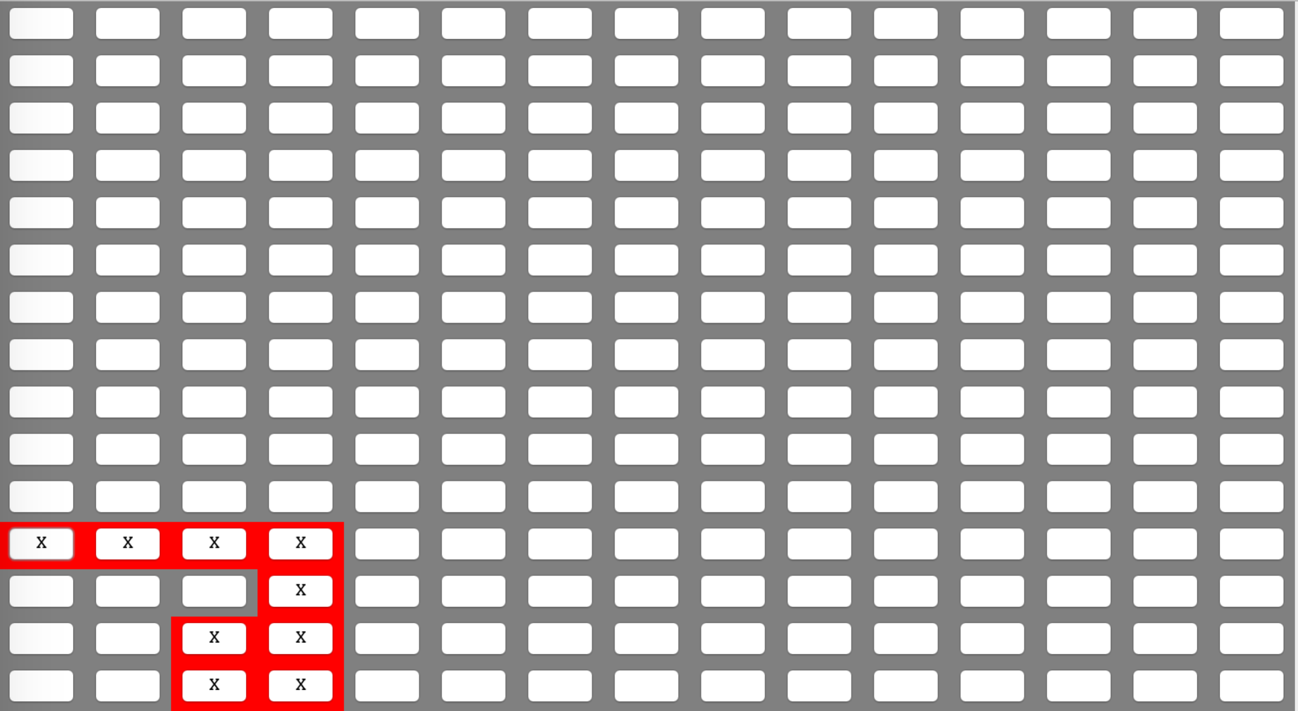

2. Click on Run Continuous button.

3. Click on Stop button after 20 seconds.

4. Record living cells position on the interface and take a screenshot:

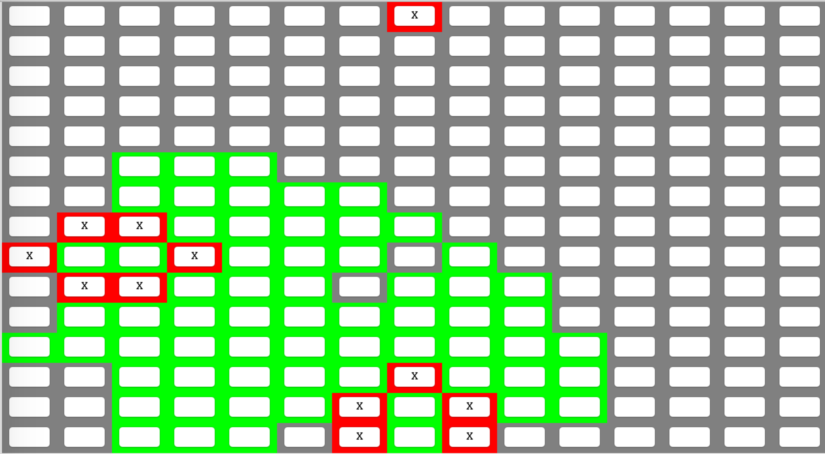

5. Exit Game of Life.

6. Modify runContinous() method, and start the game again. Then start the game by

creating a 15 * 15 world.

7. Click the exact cells as before.

[0,11],[1,11][2,11],[3,11],[3,12],[3,13],[2,13],[2,14],[2,14]

8. Click on Run Continuous button.

9. Click on Stop button after 8 seconds.

**POSTCONDITIONS:**

The cells are on the exactly the same position as it has been recorded before, and status of the cells are the same as those which runs with the original runContinuous() method.

**IDENTIFIER: Case 2**

**TEST CASE:**

Test if method runCountinous() gives the same outline of patterns before and after modification

**PRECONDITIONS:**

Creating a 15 * 15 world to start the game using original runContinuous() method.

**EXECUTION STEPS:**

1. Click cells like following:

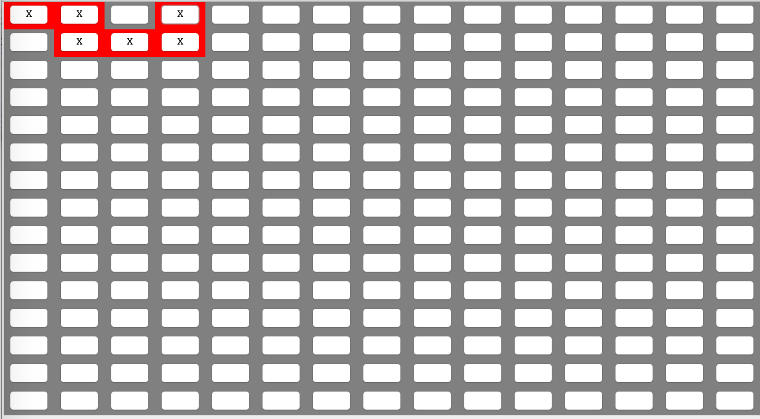

2. Click on Run Continuous button.

3. Click on Stop button after 20 seconds.

4. Record living cells position on the interface and take a screenshot:

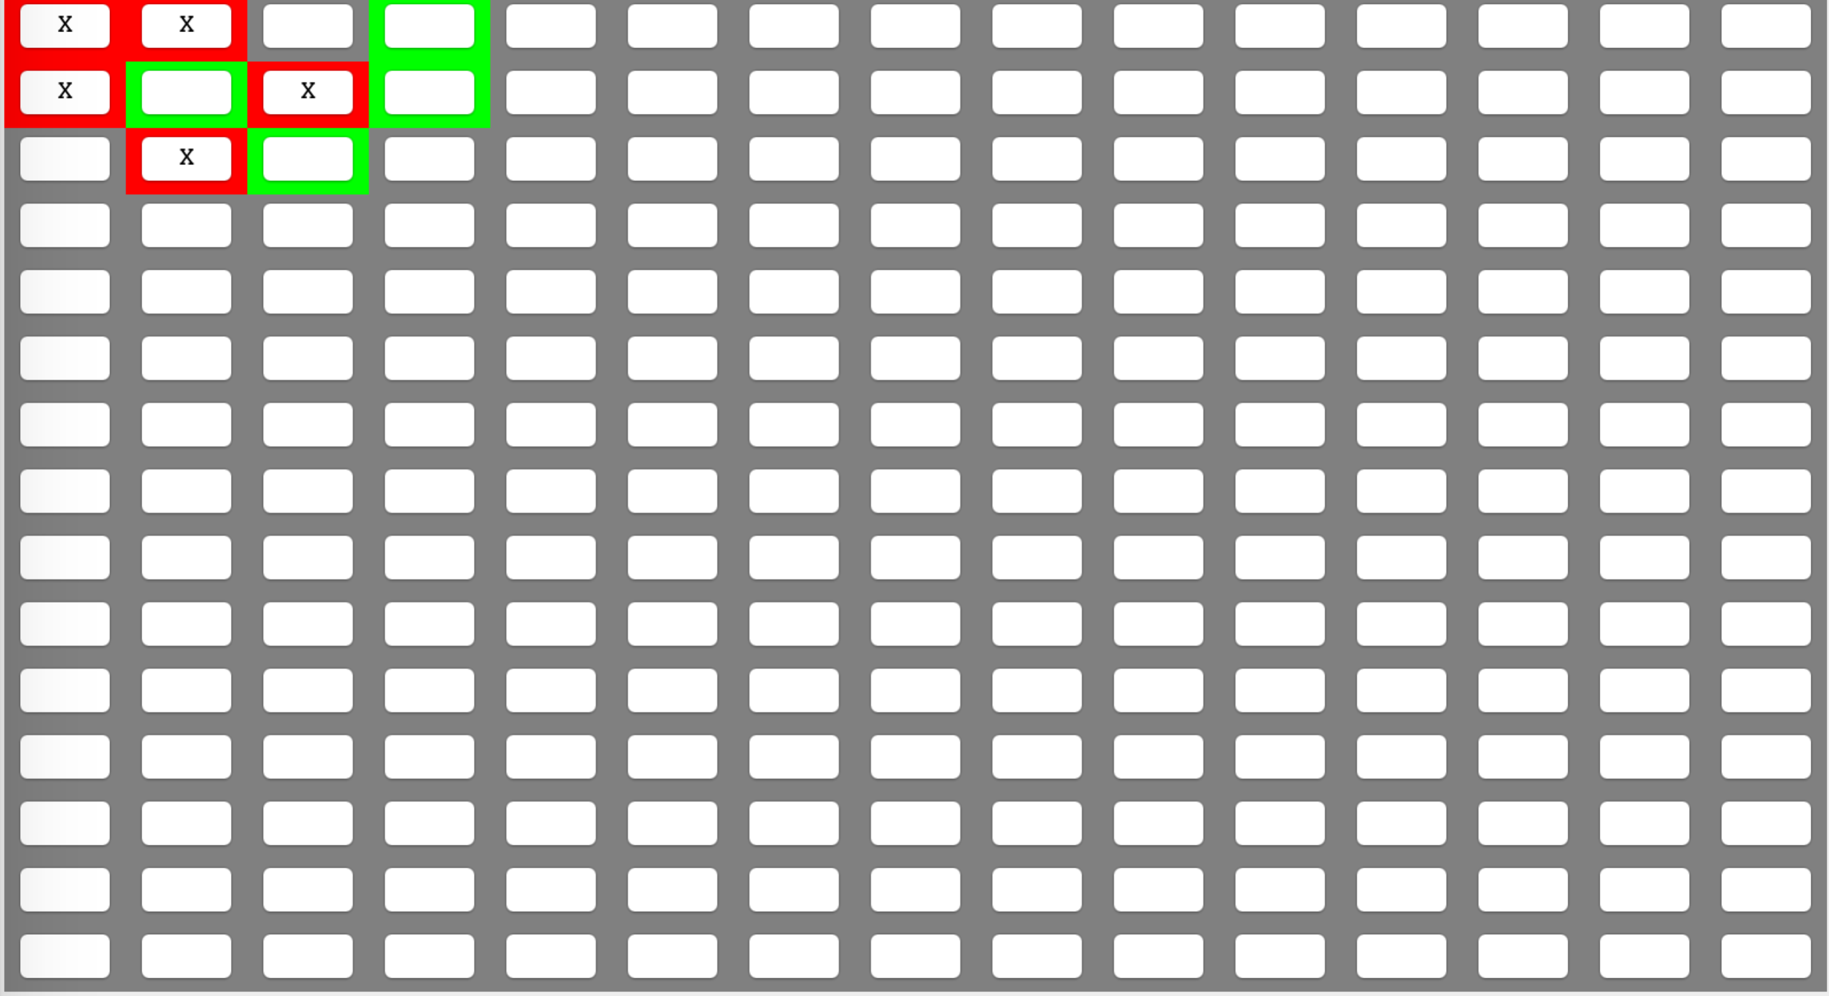

5. Exit Game of Life.

6. Modify runContinous() method, and start the game again. Then start the

game by creating a 15 * 15 world.

7. Click the exact cells as before. [0,0],[0,1][0,3],[1,3],[1,2],[1,1]

8. Click on Run Continuous button.

9. Click on Stop button after 4 seconds.

**POSTCONDITIONS:**

The cells are on the exactly the same position as it has been recorded before, and status of the cells are the same as those which runs with the original runContinuous() method.

**IDENTIFIER: Case 3**

**TEST CASE:**

Test if method runCountinous() gives the same outline of patterns before and after modification

**PRECONDITIONS:**

Creating a 15 * 15 world to start the game using original runContinuous() method.

**EXECUTION STEPS:**

1. Click cells like following:

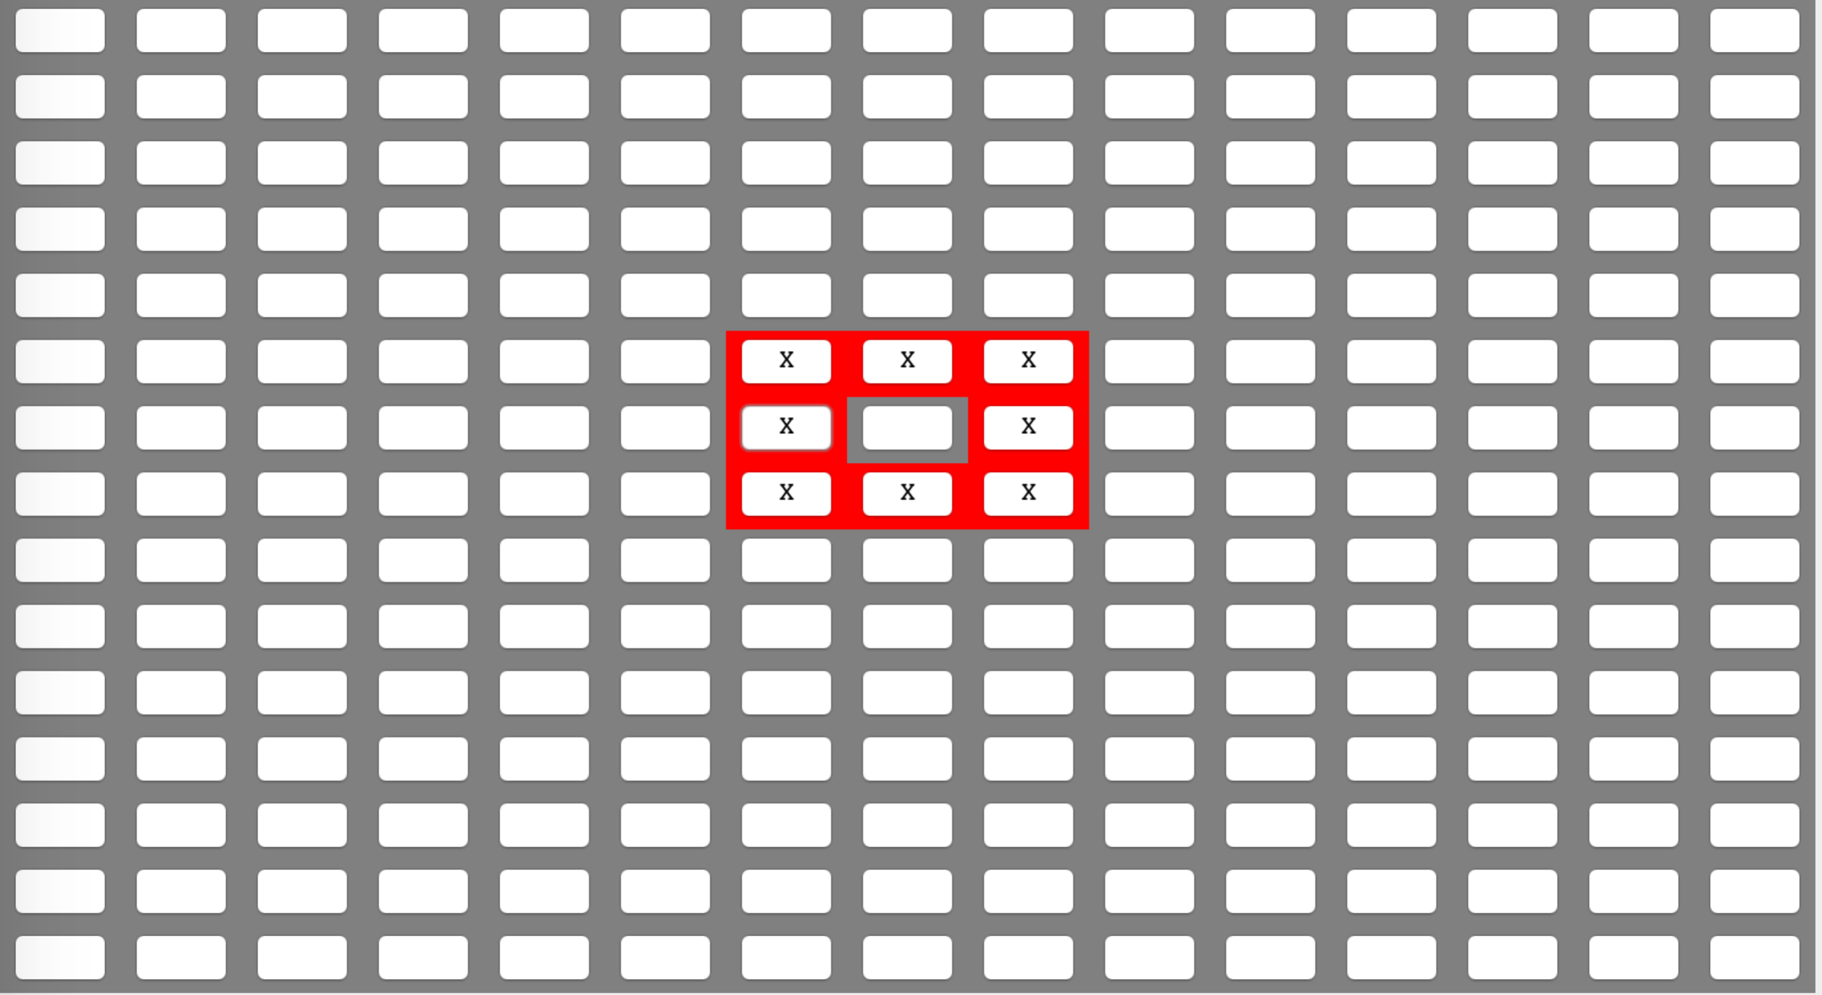

2. Click on Run Continuous button.

3. Click on Stop button after 20 seconds.

4. Record cells pattern on the interface and take screenshots of the pattern (cells are

repeating the status as it is shown in the pictures below):

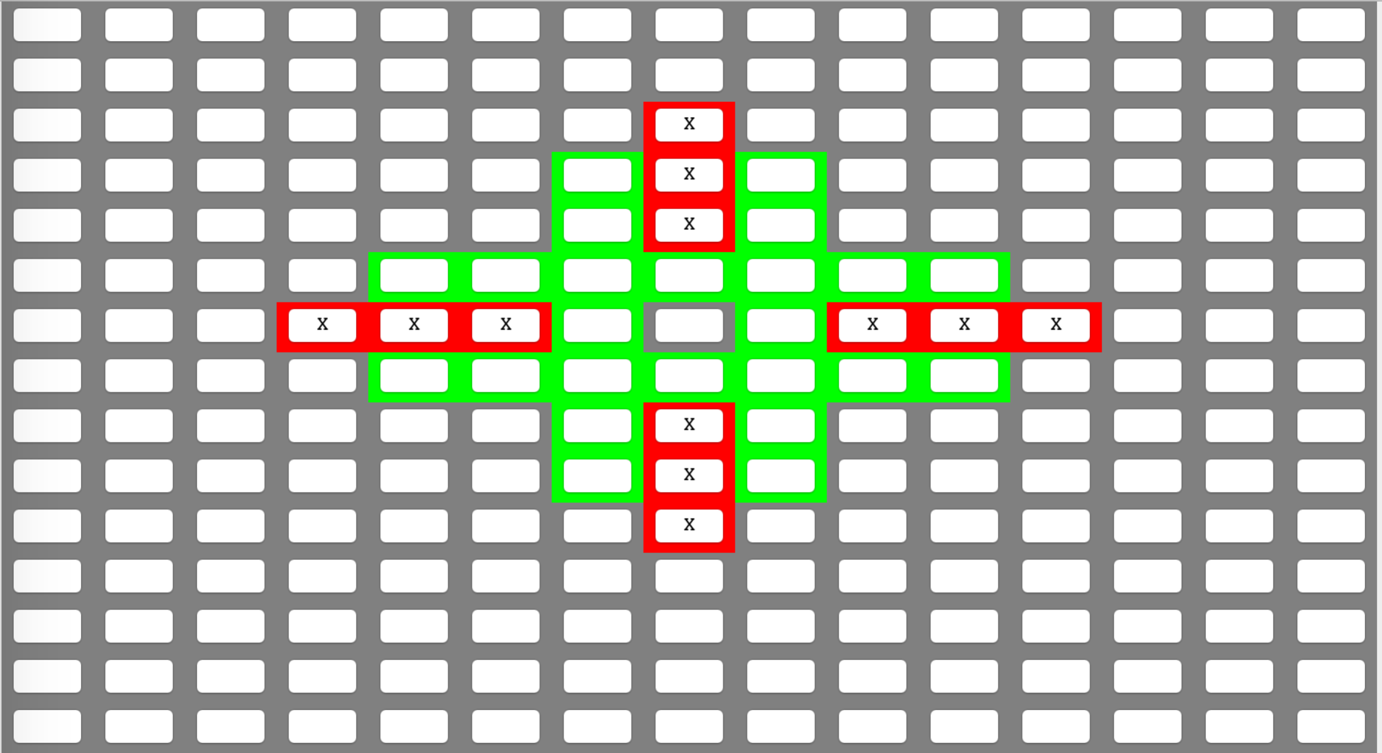 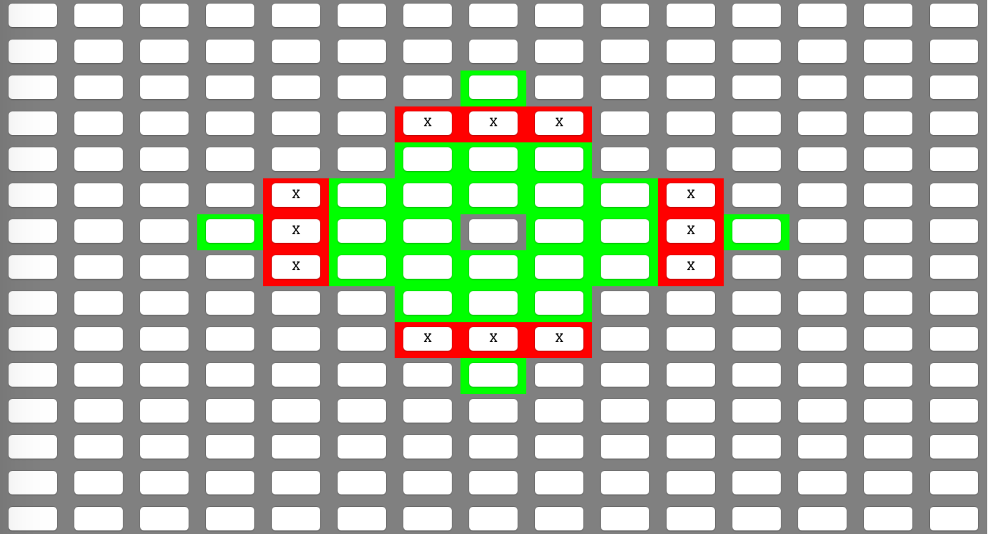

5. Exit Game of Life.

6. Modify runContinous() method, and start the game again. Then start the game by

creating a 15 * 15 world.

7. Click the exact cells as before. [6,5],[6,6][6,7],[7,7],[7,5],[8,5],[8,6],[8,7]

8. Click on Run Continuous button.

9. Click on Stop button after 8 seconds.

**POSTCONDITIONS:**

The cells are going through the exact pattern as it has been recorded before, and status of the cells are the same as those which runs with the original runContinuous() method.